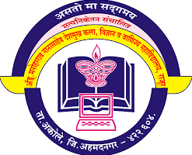
Satyaniketan’s

Adv. M. N. Deshmukh Arts, Science and Commerce College Rajur, Akole.

Department of Zoology

Result
T.Y.B.Sc. 2021-2022

Sr. No. | Name of Student | % of Marks
 | Ranmale Aishwarya Jivan | 82.91
 | Khade Jyashri Eknath | 81.73
 | Baramate Vrsha Raghunath | 79.59
 | Pabalkar Teju Sunil | 79.59
 | Mrutadak Purva Kishor | 78.86
 | Khadgir Nitin Bandu | 77.55
 | Utale Anita Kundalik | 72.41
 | Bhangare Sonali Daulat | 69
 | Bharmal Manisha Abu | 67.50

Congratulations *

